**Software Engineering**

**Assignment 8**

**M Mashiyi 216260841**

1. **State Transition Diagrams**

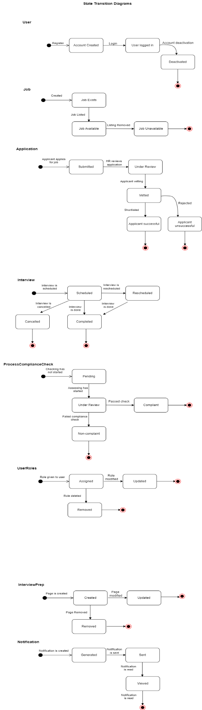

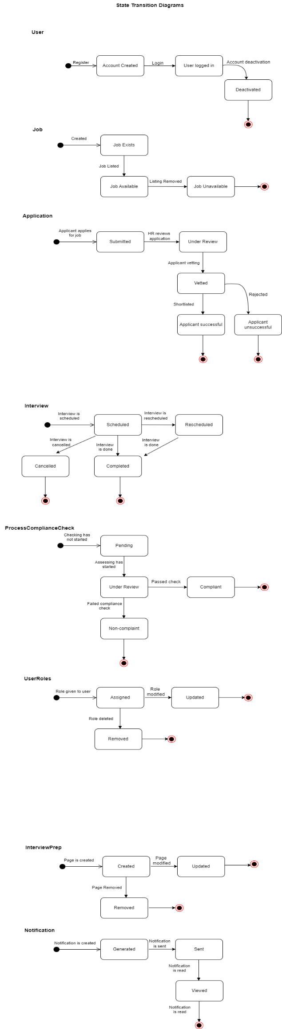

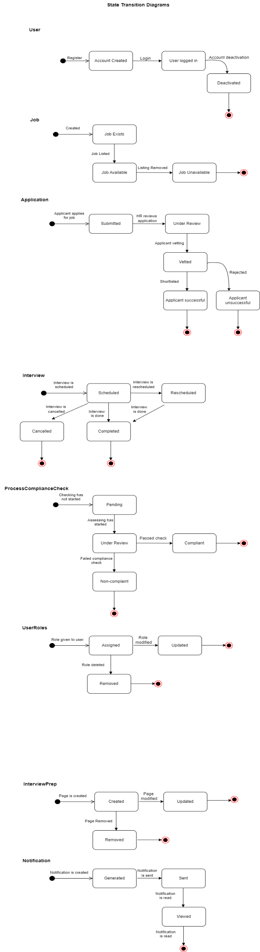

1. **Activity Diagrams**

